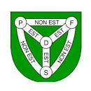
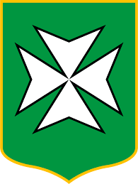

PARISHES OF ST JOHN, ST LAWRENCE, AND TRINITY
DEPUTY SURGERY DATES Till July 2023
Your Parish Deputies – Andy Howell, Elaine Millar, Hilary Jeune and Kirsten Morel - would like to welcome you to their public surgeries to discuss any parish or island wide issues, parishioners are concerned with.
Date | Time | Where | Who
Wednesday 8th Feb | 7.30pm – 9pm | St John’s Parish Assembly followed by Q&A from Connetable and 4 Deputies | All deputies
Tuesday 21st Feb | 5.30pm – 7pm | Trinity Parish Hall | Kirsten & Andy
Wednesday 22nd March | 1.15pm – 2.15pm | States Building – Deputies will meet you outside to let you in | Hilary & Elaine
Monday 27th March | 6pm – 7.30pm | St Lawrence Parish Hall | Elaine & Kirsten
Wednesday 26th April | 5.30pm – 7pm | St John Parish Hall | Hilary & Andy
Wednesday 24th May | 1.15pm – 2.15pm | States Building – Deputies will meet you outside to let you in | Kirsten & Andy
Thursday 25th May | 6pm – 7.30pm | Trinity Parish Hall | Hilary &Elaine
Wednesday 21st June | 6.30pm – 8pm | St John Parish Hall | Kirsten & Elaine
Wednesday 5th July | 6pm – 7.30pm | St Lawrence Parish Hall | Andy & Hilary

Contacts:

Andy Howell: a.howell@gov.je, 07797 888 806

Elaine Miller: e.millar2@gov.je, 07700 788 988

Hilary Jeune: h.jeune@gov.je, 07700 700995

Kirsten Morel: k.morel2@gov.je, 07797 753 101

